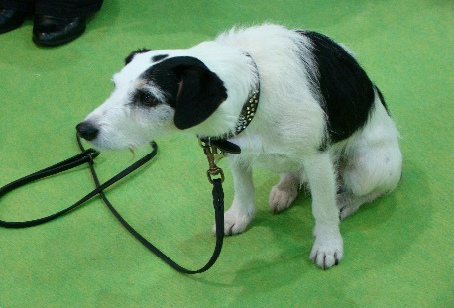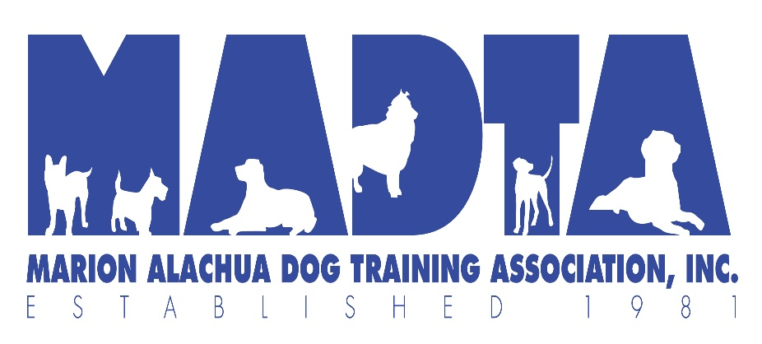
This Photo by Unknown Author is licensed under CC BY-SA

MADTA will be hosting an Obedience Sho N’ Go on January 16th 2021. This will be a great time to come and practice before the BIG MADTA Obedience trial on January 22 -24!!!!
All entries are Pre-Registration only, no day of, there will be limited space inside the building.
The fee is $6.00 per run. Registration form can be found at www.madta.org Please mail your entries forms to
Danatte Weaver @ 33 CR 540, Bushnell FL 33513 & be sure to put your license number on your check
All of MADTA COVID-19 guidelines will be followed and Social distancing will be required. This is a Sho N’ Go so we are asking people once you are done please clean up after yourself and dog(s).
For more info please call (352)461-4364 or email danesdelite@gmail.com

